Simple Lessons in Starting Seeds
By Barbara Taber
One can pretty much look anywhere on the internet and find guides on how to start seeds. However, sometimes it just helps to have the guidance of someone who is already tried starting various types of seeds.
There are lots of reasons for the home gardener to start seeds, but the biggest reasons are the vast variety of seeds that are out there, chances for an earlier harvest, and saving money. So where do we start? Well, we start with where we are going to plant and what we want to plant. Every good gardener knows that they must have an idea of how much sun and shade they have, proximity of a good water source, how long their growing season is, what their zone is, and when their last and first dates of frost occur. Once you know that information then you need to determine what exactly you want to grow: flowers, vegetables, shrubs etc. This information can be found in the Virginia Tech extension publication SPES – 170.
If you live in the city of Suffolk, Virginia, you are either gardening in Zone 7B or Zone 8. Your approximate latitude and longitude are 36.52° North and 076.27 ° West. For Zone 8, the last day of frost will be between April 5 and 15 and the first day of frost will be between November 11 and 25. This will give you between 204 and 234 growing days. For zone 7B, the last day of frost will be between April 5 and 15th with the first day of frost being between October 25 and November 5. These dates will give you approximately 203 to 214 growing days. To determine the amount of sun and shade in your garden you must do this by observation.

There are other things you must consider before starting seedlings in doors. Things such as space, lighting, available sunlight, temperature control, and the time you have to devote to tending to the seedlings must all be considered.
Now it is time to buy your seed. There are lots of places to order seed online or you can purchase it in the garden department of your favorite store. Where you choose to purchase your seed is entirely up to you, but you will find a wider variety in online seed vendors and seed exchanges. Everything you need to know about growing a particular seed is listed on the back of the package of seeds. Pay particular attention to the planting depth, when to start the seeds, whether they are direct garden sowing or can be started indoors, and the days to harvest.
A note here about the days to harvest…
For seeds started indoors, the “days to harvest’ starts when the seedlings are transplanted to the garden.
For directly sown seeds, the “days to harvest” usually starts when the seeds germinate, and the plants show their first set of true leaves.
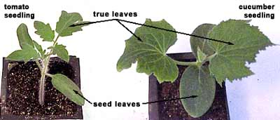
https://garden.org

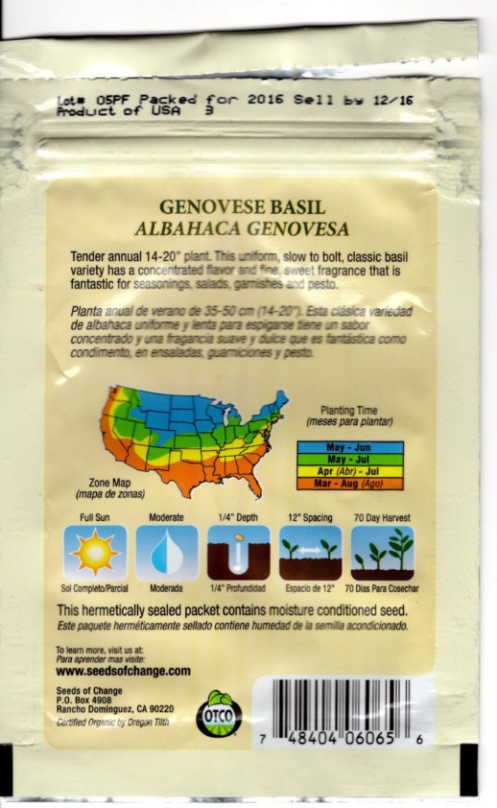

Some of the seeds will require special treatment and that information should be on the packet. For example, some seeds require light to germinate while others require darkness. Some seeds might require soaking in warm water overnight while other seeds require the scraping or scarification of the seed capsule. There are even seeds that require cold stratification. This just means that the seeds need to be put in the refrigerator or the freezer for a specific number of days before planting. Sometimes that information is on the packet and sometimes you must look it up on the Internet.

While you are waiting for your seeds to arrive you might want to gather up the basic necessities such as seed starting medium, seed flats, heating mats, labels, and a paint pen. When it comes to seed flats, you may choose to use individual pots or the flats that come with individual little cups. You may also like to purchase flats that come with clear plastic domes. There are many different seed starting systems available both online and in your local stores. You can spend as much or as little money as you desire. The choice is yours. I personally use a commercial seed starting system from a seed distributor.
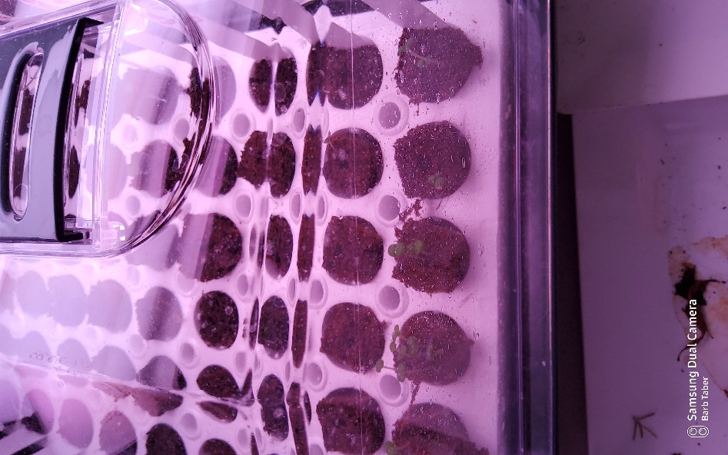

A sterile seed starting mixture is very important! That is the reason we do not use garden soil for starting our seeds indoors. It is best if you create your seed starting mix from a mixture of perlite or vermiculite, healthy compost, and potting soil topped with a good layer of commercial starting mix. Due to environmental concerns most gardeners are moving away from using peat moss and peat pots. Even the commercial Jiffy pots, little discs wrapped in net that expand once you put them in warm water, are being made from something other than peat moss.

So now it is time to start those seeds! I am going to give these to you in steps:
Step 1: Assemble all your materials in a place where you do not mind getting soil all over the place.
Step 2: In a large tub mix all your soil and moisten it with warm water until it is crumbly and moist, not soggy. In a separate tub do the same to your sterile seed starting mix.
Step 3: Carefully fill each of the sterile pots or flats with your soil mixture and top with the sterile seed starting mix.
Step 4: Before you tear into the packets of seeds make labels! Use the paint pen and either plastic or wooden labels to indicate exactly what seeds are in which pots!
Step 5: Carefully opening a single packet of seeds, plant one or two seeds in each pot. The number of pots that you plant depends on how many plants you want. So, if you want 4 tomato plants, you are going to plant 4 pots with two seeds each. When planting the seeds pay close attention to whether they need to be buried or left on the surface. For instance, the Genovese Basil in the picture above, needs to be planted ¼ of an inch deep.
Step 6: Before moving to the next packet of seeds, make sure you label the seeds you have just planted.
Step 7: Continue planting and labeling until the flat is full. Then cover the flat with either a plastic dome or plastic wrap. Place the flats under a grow light which is positioned about 2 to 3 inches above the surface. Because of the proximity of the grow lights, you can see that I have to pull out the trays to remove the domes.
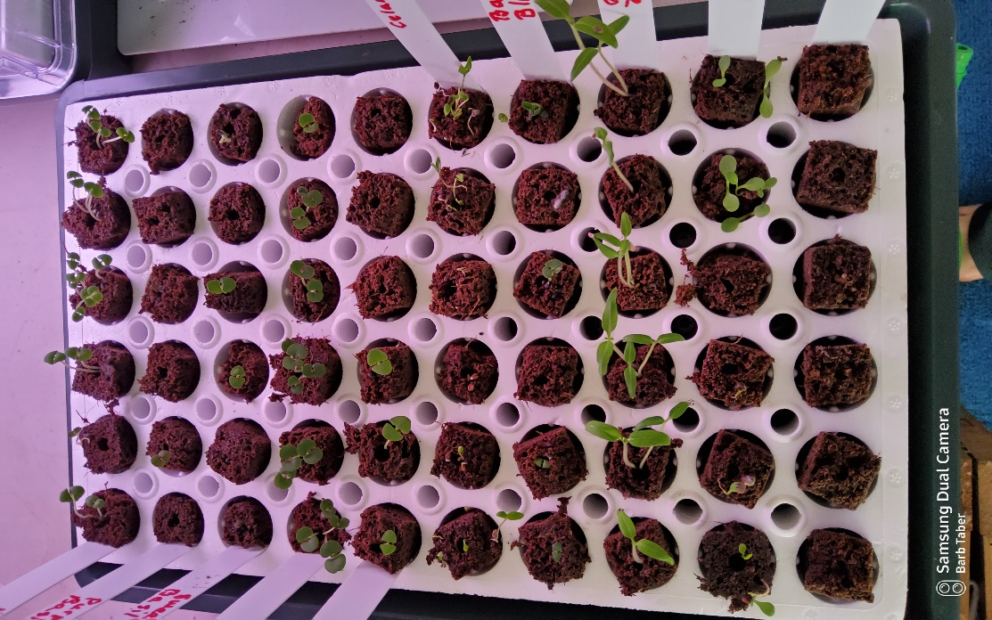
These seedlings are about two weeks old.

If you are using a heat mat, you will, at this point, want to place the flat on top the mat. You will want to run your plant light for between 10 and 12 hours a day. It is best if you use a shop light that takes two bulbs, one blue and one red. This will help produce strong, stocky plants. It also helps to rotate the flats and adjust the light height as the plants grow.

Step 8: The time it takes for seeds to sprout depends on the plant. Some seeds will sprout in three days while others may take seven or eight days, or even longer. Again, that information will be on the seed packet as “days to germination”. So, while you’re waiting for the seeds to sprout you need to think about what you’re going to use to hold your new transplants. The Internet is full of all sorts of ingenious containers to use to transplant your little babies into larger pots while they wait to go out into the garden. Just be sure to clean the pots, soak them in a 10% bleach solution, and thoroughly rinse.
Once the seeds have sprouted and have their first true leaves, you should consider adding plant food to the tray water. Since these are tiny sprouts you will only want to use half strength fertilizer, every 10 to 14 days, in the water. If you wish to grow organic, then use organic fertilizer. Otherwise, any plant fertilizer will work.
If you’re growing tomatoes, you might consider using 16-ounce plastic cups. Tomatoes are one of those few plants that will route all along the stem. So, if your baby plants get to stretched out and leggy, they can be rescued. Simply place the plant in a plastic cup (put several holes in the bottom of the cup) and fill it up with soil to just below the first true leaves. If they get really leggy you can even gently pull some of the leaves off and plant them all the way up the stem. (Next Level Gardening https://youtu.be/5FiBryH75SY)
Most of your baby plants can be placed in four-inch nursery pots, soup cans with holes in the bottom, or those 16-ounce plastic cups previously mentioned. Personally, I like to place the small pots in a larger tray, such as an aluminum roasting pan, so that I can water them from the bottom. That does not mean letting your plants sit knee-deep in water. You just want to water them enough to keep the soil moist and you want to water them from the bottom. Frequent watering from the top will invite diseases, mold, and rot.
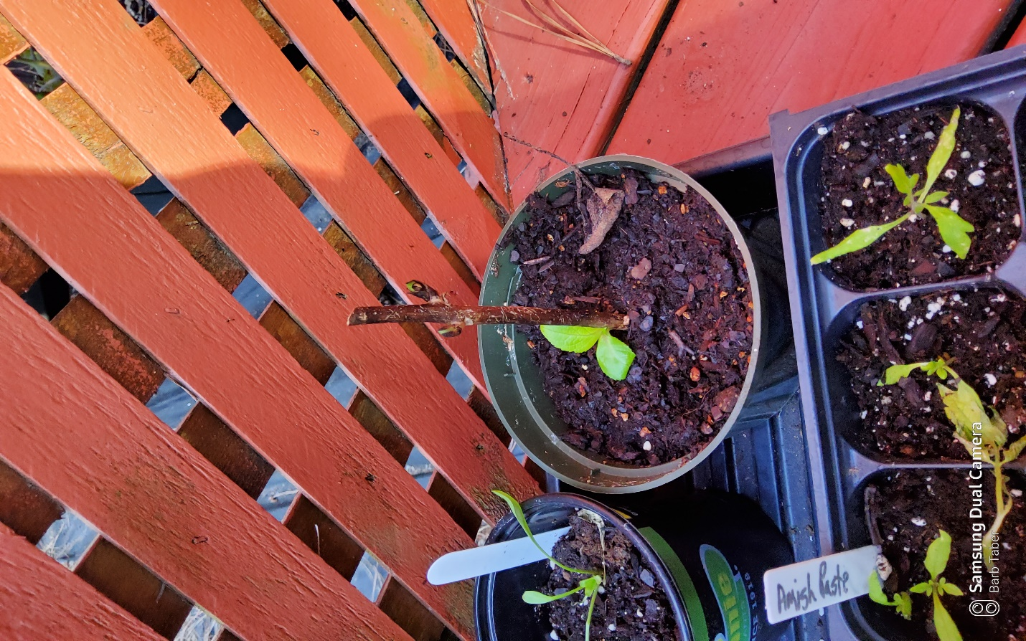
Note that the tray under the pots is dry but the individual pots are moist. Also note that the tomatoes and the echinacea are labeled but the hydrangea is not labeled. So, do is say say not as I do…

Step 9: Conditioning your plants is called hardening off. This is a simple process where you expose the plants to natural sunlight, wind, and normal growing conditions. If you must keep your plants in your house, you can use a fan to gently blow across the plants and mimic a gentle breeze. When you start to move the plants outdoors you do this in stages.
1 to 2 weeks before the hardening off process transplant, fertilize, and water your plants.
Day One: Set your plants in the shade for several hours then bring them back in the house.
Day Two: Place your plants in dappled sunlight for several hours then bring them back into the house.
Day Three: Place the plants in full sunlight for several hours. If the plants are shade plants, then keep them in the dappled sun or shade area.
Day four: After checking the weather you should transplant your plants into their permanent location. It is best to transplant in the late afternoon or on a cloudy day. Always make sure that the plant roots have good soil contact and that you have planted them no deeper than the soil level in the pot... The exception to the depth, as mentioned before, is the tomato plant. Make sure to water the plants after they have been transplanted.

Happy Gardening!

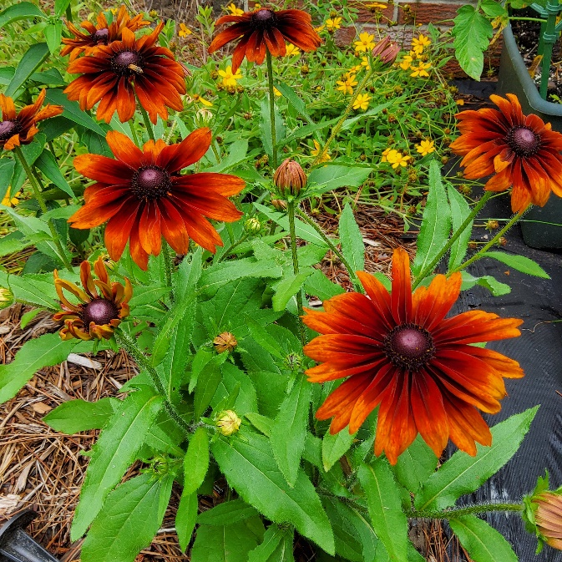
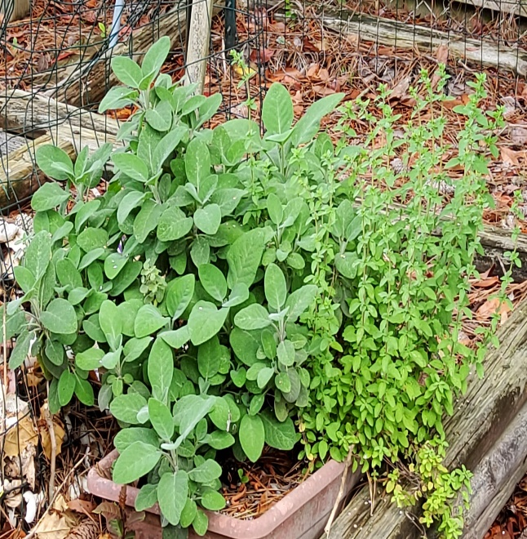
Cheyenne Autumn Echinacea Sage and Oregano

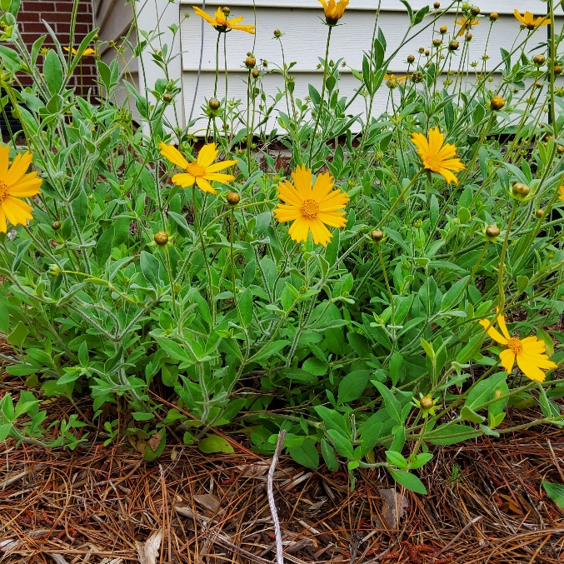
Lanceleaf Coreopsis
Bibliography:
Bubel, Nancy. (1988). The New Seed-starters Handbook, Rodale Press

https://www.burpee.com/gardenadvicecenter/areas-of-interest/seed-starting/indoor-seed-starting/article10002.html
https://joegardener.com/?s=seed+starting
https://www.nextlevelgardening.tv/

Virginia’s Home Garden Vegetable Planting Guide: Recommended Planting Dates and Amounts to Plant
https://www.pubs.ext.vt.edu/content/dam/pubs_ext_vt_edu/426/426-331/SPES-170.pdf
https://digitalpubs.ext.vt.edu/vcedigitalpubs/2283154249827475/MobilePagedReplica.action?pm=2&folio=1#pg1

Plant Propagation From Seed
https://www.pubs.ext.vt.edu/content/dam/pubs_ext_vt_edu/426/426-001/426-001.pdf

Seed For The Garden:
https://www.pubs.ext.vt.edu/content/dam/pubs_ext_vt_edu/426/426-316/426-316_pdf.pdf

Good Seed Source:
https://www.southernexposure.com/

